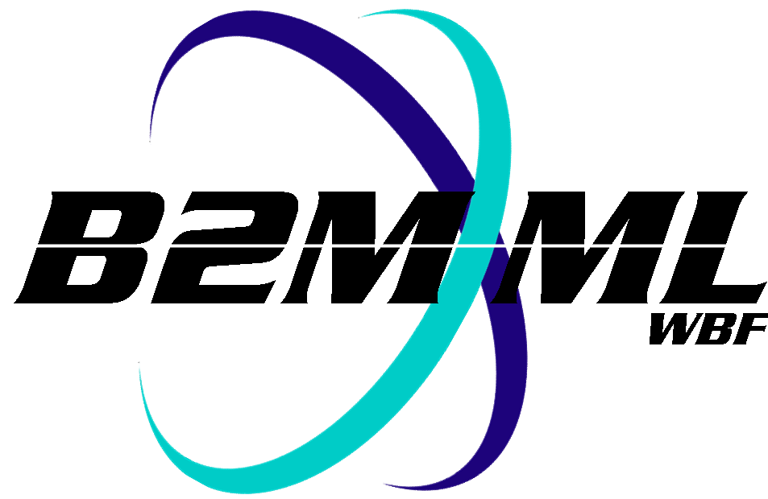
Business To Manufacturing
Markup Language
Batch Markup Language
Version 0500 – August 7, 2011
Errata


IMPORTANT: While the information, data, and standards provided in this publication were developed and are presented in good faith in accordance with a reasonable process that was subject to intellectual property and antitrust policies to benefit the industry as a whole, the publication is provided “as is” for information and guidance only, and there is no representation or warranty of any type or kind, including but not limited to warranties of merchantability or fitness for a particular purpose, and no warranty that use of the information, data, or standards will not infringe patent, copyright, trademark, trade secret, or other intellectual property rights of any party.

B2MML-V05-Common.xsd
The following problem has been identified in the schemas. You should make the identified changes to the schemas in your local copies to correct the problems:
The group definition ProductProductionRuleIDGroup has an incorrect type for the ProductProductionRuleID element.
It is defined as:
<xsd:group name="ProductProductionRuleIDGroup">
<xsd:sequence>
<xsd:element name="ProductProductionRuleID"
type="ProductionRequestIDType" minOccurs="0"/>
<xsd:element name="Version"
type="VersionType" minOccurs="0"/>
</xsd:sequence>
</xsd:group>

It should be defined as:
<xsd:group name="ProductProductionRuleIDGroup">
<xsd:sequence>
<xsd:element name="ProductProductionRuleID"
type=" ProductProductionRuleIDType " minOccurs="0" />
<xsd:element name="Version"
type="VersionType" minOccurs="0"/>
</xsd:sequence>
</xsd:group>

BatchML-V05-BatchInformation.xsd
The following problem has been identified in the schemas. You should make the identified changes to the schemas in your local copies to correct the problems:
The extension element in the FromIDType (line 682) is incorrect.
It is defined as:
<!-- Complex Type with Extension -->
<xsd:complexType name = "FromIDType">
<xsd:sequence>
<xsd:element name = "FromIDValue" type = "xsd:string" />
<xsd:element name = "FromType" type = "FromTypeType" />
<xsd:element name = "IDScope" type = "IDScopeType" />
<xsd:group ref = "Extended:FromEquipmentID"
minOccurs="0" maxOccurs="1"/>
</xsd:sequence>
</xsd:complexType>

It should be defined as:
<!-- Complex Type with Extension -->
<xsd:complexType name = "FromIDType">
<xsd:sequence>
<xsd:element name = "FromIDValue" type = "xsd:string" />
<xsd:element name = "FromType" type = "FromTypeType" />
<xsd:element name = "IDScope" type = "IDScopeType" />
<xsd:group ref = "Extended:FromID"
minOccurs="0" maxOccurs="1"/>
</xsd:sequence>
</xsd:complexType>

B2MML-V0500-OperationsDefinition.xsd
The following problem has been identified in the schemas. You should make the identified changes to the schemas in your local copies to correct the problems:
The OperationsMaterialBillType has a wrong definition for the OperationsMaterialBillItem. The maxOccurs=”unlimited” is missing in the element definition. It is:

<xsd:complexType name="OperationsMaterialBillType">
<xsd:sequence>
<xsd:element name="ID" type="IdentifierType"/>
<xsd:element name="Description" type="DescriptionType" minOccurs="0"/>
<xsd:element name="OperationsMaterialBillItem"
type="OperationsMaterialBillItemType"
minOccurs="0"/>
<xsd:group ref="Extended:OperationsMaterialBill" minOccurs="0"/>
</xsd:sequence>
</xsd:complexType>

It should be defined as:

<xsd:complexType name="OperationsMaterialBillType">
<xsd:sequence>
<xsd:element name="ID" type="IdentifierType"/>
<xsd:element name="Description" type="DescriptionType" minOccurs="0"/>
<xsd:element name="OperationsMaterialBillItem"
type="OperationsMaterialBillItemType"
minOccurs="0" maxOccurs="unbounded"/>
<xsd:group ref="Extended:OperationsMaterialBill" minOccurs="0"/>
</xsd:sequence>
</xsd:complexType>

